ELECTROMAGNETIC WAVES

Scope and Structure of the Lecture
- Chapter: Electromagnetic Waves (EM Waves) for JEE Main and JEE Advanced.
- Weightage and Nature: A compact chapter with extremely high yield. Questions are straightforward once key concepts and equations are understood.
- Main Topic Distribution:
1. Displacement Current (I_d) and Paradoxes
2. Maxwell's Equations
3. Properties of EM Waves
4. Wave Equations and Problem Solving

Displacement Current (I_d) and Circuit Foundations

Charge accumulates on capacitor plates as a function of time:
q(t) = C*V*(1 - e^(-t/(R*C)))
where q(t) is instantaneous charge, C is capacitance, V is battery voltage, R is circuit resistance, and t is time.

Conduction Current in Wires (I_c):
Conduction current flowing through connecting wires is the rate of flow of charge:
I_c = dq / dt = d/dt [ C*V*(1 - e^(-t/(R*C))) ]
I_c = (V / R)*e^(-t / (R * C))
- Initial Conduction Current (t = 0): I_c = V / R (capacitor offers zero opposition, acts as short circuit).
- Steady State Conduction Current (t → ∞): I_c = 0 (capacitor fully charged to q = CV, acts as open circuit).

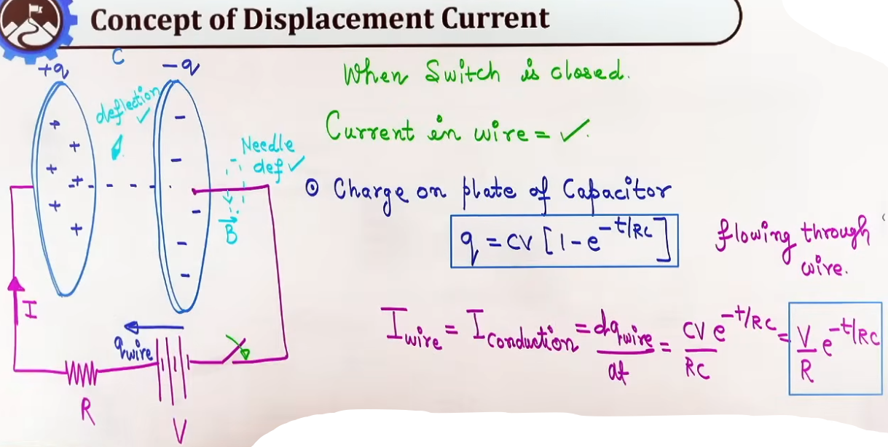
The Two Historical Paradoxes
Paradox 1 (Current Continuity Paradox):
- In connecting wires, conduction current I_c flows due to moving charge carriers (electrons).
- Inside the gap between capacitor plates, there is air, vacuum, or dielectric material (no physical electrons cross the gap, so I_c = 0).
- This implies a broken/open circuit inside the gap, creating an apparent violation of Kirchhoff's Current Law and continuity of electric current. How can current flow in wires if the circuit is open at the capacitor gap?
Paradox 2 (Magnetic Field Deflection Paradox):
- A magnetic compass needle placed near connecting wires deflects due to the magnetic field B produced by wire current I_c.
- When the compass needle is placed BETWEEN capacitor plates during charging, it ALSO shows deflection!
- Deflection proves a magnetic field exists in the gap despite zero conduction current (I_c = 0) and no physical charge flow between plates. What force acts on the needle and creates this magnetic field inside the plates?

Maxwell's Resolution and Derivation of Displacement Current
- Maxwell's Hypothesis: By nature's fundamental symmetry, if a time-varying magnetic field induces an electric field (Faraday's Law), a time-varying electric field must generate a magnetic field.

- Electric Field Between Parallel Plates:
E = σ/ε₀ = (CV/Aε₀)*(1 - e^(-t/RC))
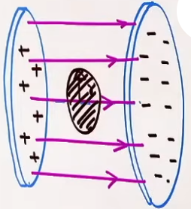
where σ = q/A is surface charge density, A is plate area, ε₀ is permittivity of free space. { q = CV(1 – e^(-t/(R*C))) }

- Electric Flux Through Area of radius 'r': # EF time k sath vary kar rahi h position k sath nahi
Φ_E = E*πr² = (CVπr²/Aε₀) * (1 – e^(-t/RC))

- From Gauss' law Φ_E = qᵢ/ε₀ or qᵢ = Φ_E*ε₀:
qᵢ = (CVπr²/A) * (1 – e^(-t/RC))

- Rate of change of this charge # this current is called displacement current
I_d = dqᵢ/dt = d(Φ_E*ε₀)/dt = (ε₀)(d(Φ_E)/dt) OR
I_d = dqᵢ/dt = (CVπr²/A*RC)*(e^(-t/RC))
I_d = (V/R)(πr²/A) * (e^(-t/RC))
- If πr² = Area of the plate
I_d = (V/R) * (e^(-t/RC)) # which is equal to conduction current

- Total Circuit Current:
I_total = I_c + I_d
In connecting wires: I_c = (V/R)*e^(-t/(RC)), I_d = 0. Total = I_c.
Inside capacitor gap: I_c = 0, I_d = (V/R)*e^(-t/(RC)). Total = I_d.
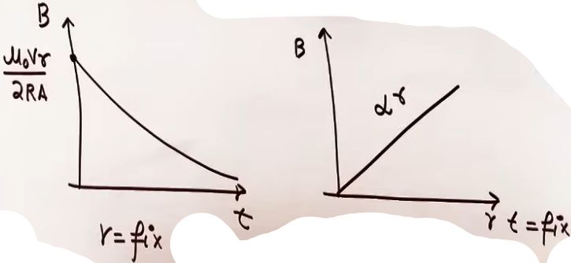
Total current remains continuous and equal to (V/R)*e^(-t/(RC)) everywhere in the circuit at all times.

At t = 0: I_c = I_d = V/R.
At t → ∞: I_c = I_d = 0.
Both I_c and I_d decay exponentially with time.

Spatial and Temporal Distribution of Internal Magnetic Field
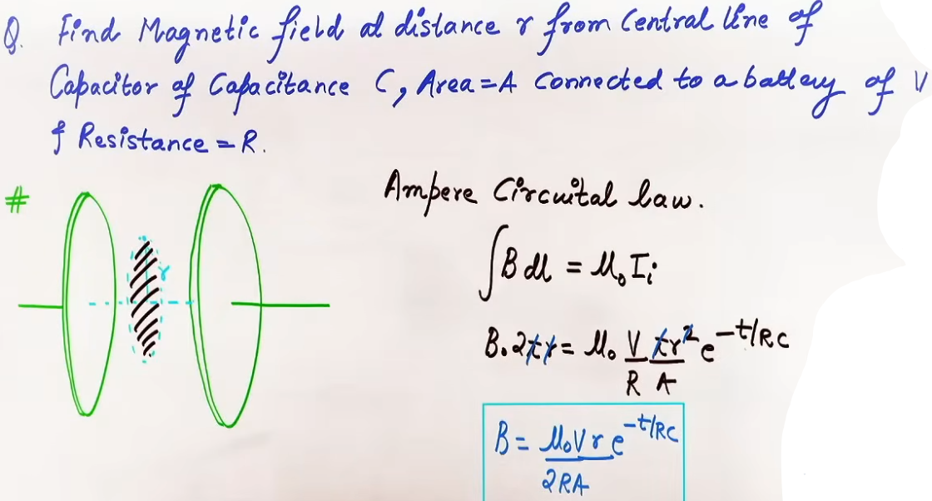
- Magnetic Field Variations:
1. Radial Dependence (fixed t): B ∝ r. Magnetic field is zero at central axis (r = 0) and grows linearly to a maximum at plate edge (r = R_plate).
2. Time Dependence (fixed r): B ∝ e^(-t / (R * C)). Decays exponentially from maximum at t = 0 to zero at t → ∞ (fully charged steady state).

Maxwell's Four Fundamental Equations

Maxwell unified electrostatics, magnetism, and induction into 4 fundamental equations governing all electrodynamics:

1. Gauss's Law for Electrostatics:
∮E·dA = q_in/ε₀

2. Gauss's Law for Magnetism:
∮B·dA = 0

3. Faraday's Law of Electromagnetic Induction:
∮E·dl = -dΦ_B / dt
Physical Meaning: A changing magnetic field generates an induced non-conservative electric field forming closed loops.

4. Ampere-Maxwell Law (Modified Ampere's Law):
∮B·dl = μ₀*(I_c + I_d) = μ₀[I_c + ε₀*(dΦ_E / dt)]
Physical Meaning: Magnetic fields are produced both by moving electric charges (conduction current I_c) and by time-varying electric fields (displacement current I_d).

FORMULA SHEET

- Capacitor Charge Equation:
q(t) = C * V * (1 - e^(-t / (R * C)))
Conditions: RC charging circuit starting from uncharged capacitor at t = 0.

- Conduction Current in Wires:
I_c = dq / dt = (V/R)*e^(-t/(RC))
Units: Ampere (A)

- Displacement Current:
I_d = ε₀ * (dΦ_E / dt)
Units: Ampere (A)

- Total Circuit Current:
I_total = I_c + I_d = (V/R)*e^(-t/(RC))
Continuity Condition: Valid at all points in circuit at all times t.

- Electric Field Between Capacitor Plates:
E(t) = σ(t)/ε₀ = q(t)/(Aε₀) = [ CV(1 - e^(-t/(RC))) ]/(A * ε₀)
Units: Volt per meter (V/m) or Newton per Coulomb (N/C)

- Electric Flux Between Capacitor Plates:
Φ_E = E*A = q/ε₀

- Internal Magnetic Field (r ≤ R_plate):
B(r, t) = (μ₀*I_c*r)/(2*A) = (μ₀*I_c*r)/(2*π*R_plate²)
B(r, t) = [ (μ₀*V*r)/(2*A*R) ]*e^(-t/(RC))
Units: Tesla (T)
Conditions: Inside capacitor plate boundary r ≤ R_plate.

- Maximum Internal Magnetic Field (at plate edge r = R_plate):
B_max(t) = (μ₀*I_c)/(2*π*R_plate)

- Ampere-Maxwell Law:
∫B·dl = μ₀*(I_c + I_d) = μ₀*I_c + μ₀*ε₀*(dΦ_E / dt)
- Maxwell's Equations Set:
1. ∫ E · dA = q_in / ε₀
2. ∫ B · dA = 0
3. ∫ E · dl = -dΦ_B / dt
4. ∫ B · dl = μ₀ * I_c + μ₀ * ε₀ * (dΦ_E / dt)

CONCEPT CONNECTIONS
- Connection to Magnetism and Ampere's Law:
Original Ampere's Law ∫ B · dl = μ₀ * I_c was incomplete because it failed inside capacitor gaps. Maxwell added μ₀ * I_d to restore mathematical consistency across arbitrary closed surfaces.

Comparison Table of Current Types:
Property | Conduction Current (I_c) | Displacement Current (I_d)
Physical Origin | Drift of actual charge carriers (electrons) | Time-varying electric flux (dΦ_E / dt)
Location in RC Circuit | Connecting wires and resistor | Gap between capacitor plates
Formula | I_c = dq / dt | I_d = ε₀ * (dΦ_E / dt)
Magnitude in Charging Gap | Zero (I_c = 0) | Equal to wire current: (V/R) e^(-t/RC)
Magnitude in Wires | Equal to (V/R) e^(-t/RC) | Zero (I_d = 0)
Source of Magnetic Field | Yes (around wires) | Yes (inside capacitor gap)

COMMON MISTAKES AND TRAPS

Mistake | Why Students Make It | Correct Approach / Thinking
Assuming I_d differs in magnitude from I_c | Believing displacement current is smaller than conduction current | Inside the capacitor gap, total displacement current I_d EXACTLY equals conduction current I_c flowing in connecting wires (I_d = I_c = dq/dt).
Thinking B-field is uniform inside capacitor plates | Assuming parallel plate symmetry creates uniform magnetic field | Electric field E is uniform, but magnetic field B grows linearly with radial distance r from center axis: B(r) ∝ r.
Forgetting ε₀ factor in I_d formula | Writing I_d = dΦ_E / dt | Displacement current is I_d = ε₀ * (dΦ_E / dt). Electric flux rate must be multiplied by ε₀ to get units of current (Amperes).
Confusing steady state with charging phase | Expecting magnetic field in fully charged capacitor | In steady state (t → ∞), charge q = CV is constant, dE/dt = 0, so I_d = 0 and B = 0. B-field exists ONLY while capacitor is charging or discharging!

Key Observations:
1. Displacement current arises from time-varying electric flux, not moving physical charge carriers.
2. Continuity of current across the circuit is preserved by I_c in wires and I_d in capacitor gap.
3. B-field inside circular capacitor plates varies linearly with radius r (B = 0 at center r = 0; B = B_max at edge r = R_plate).
4. Internal B-field decays exponentially with time during charging and drops to zero at steady state (t → ∞).
5. Maxwell's 4 equations completely unify electrostatics, magnetism, induction, and electromagnetic radiation.
GENERAL WAVE MECHANICS AND EM WAVE PROPERTIES
General Wave Mechanics and Traveling Transverse Wave Equations

- Definition of a Wave:
A wave is a self-propagating disturbance or energy transport through space or a material medium without any net movement of bulk matter.

- Transverse Waves vs. Longitudinal Waves:
1. Transverse Wave: The oscillations of the particles or field vectors occur in a direction perpendicular to the direction of wave propagation (energy transfer). Examples: Electromagnetic waves, waves on stretched strings, surface water ripples.
2. Longitudinal Wave: The oscillations of particles occur parallel to the direction of wave propagation. Examples: Sound waves in air and fluids, compression waves in springs.

- General Equation of a Traveling Transverse Wave:

y(x, t) = A sin(k*x ± ω*t + ϕ) or y(x, t) = A cos(k*x ± ω*t + ϕ)

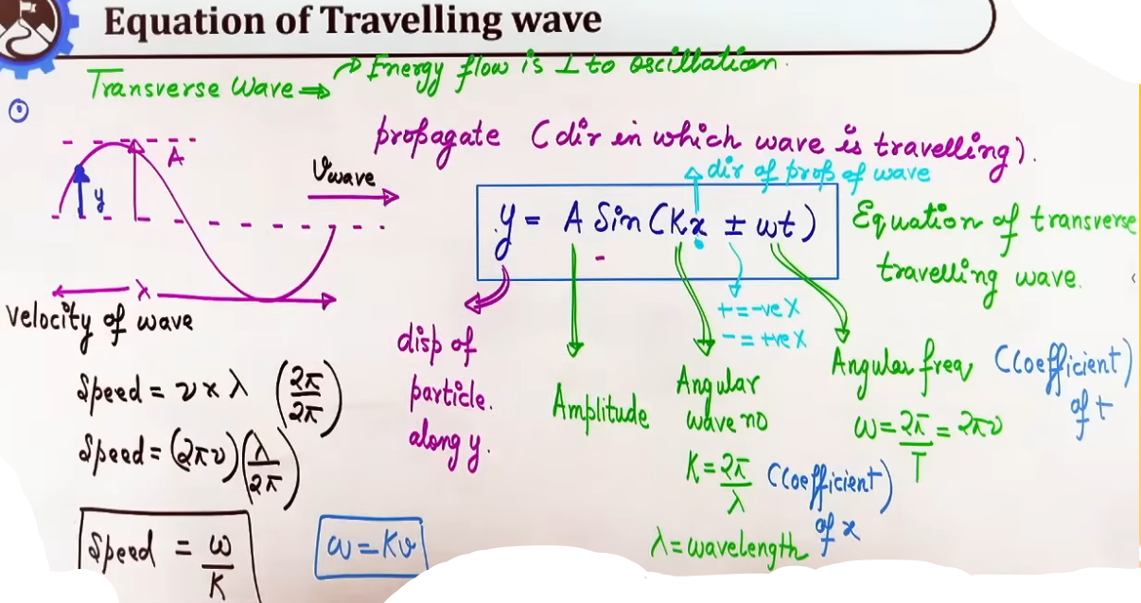
where:
k = Angular wave number (propagation constant). Formula: k = 2π / λ. Unit: rad/m.
(k*x ± ω*t + ϕ) = Instantaneous phase angle at position x and time t.
ϕ = Initial phase constant (phase angle at x = 0, t = 0).

- Wave Speed / Phase Velocity (v):
The speed at which the wave profile and energy travel through space.
Formula: v = ν*λ = (2πν)/(2π/λ) = ω/k
Teacher's Mnemonic: ω = k*v ("Oomega = Kendra Vidyalaya" or "ω = KV").

Properties and Physics of Electromagnetic Waves

- Sources of Electromagnetic Waves:
1. Charge at Rest (v = 0, a = 0): Produces a static Electric field E only.
2. Charge Moving with Uniform Velocity (v = constant, a = 0): Produces constant Electric field E and Magnetic field B. No radiation or EM wave is emitted.
3. Accelerated or Oscillating Charge (a ≠ 0): Emits Electromagnetic (EM) Waves / radiation continuously into surrounding space.

- Non-Mechanical Nature:
EM waves do not require any physical or material medium for propagation. They travel unhindered through vacuum as well as dielectric media.

- Light Vector / Optical Vector:
The Electric field vector E is designated as the "Light Vector" because visual sensations in the retina (rod and cone cells) are triggered exclusively by electric field forces. All optical phenomena (reflection, refraction, interference, diffraction, polarization) are governed by E.

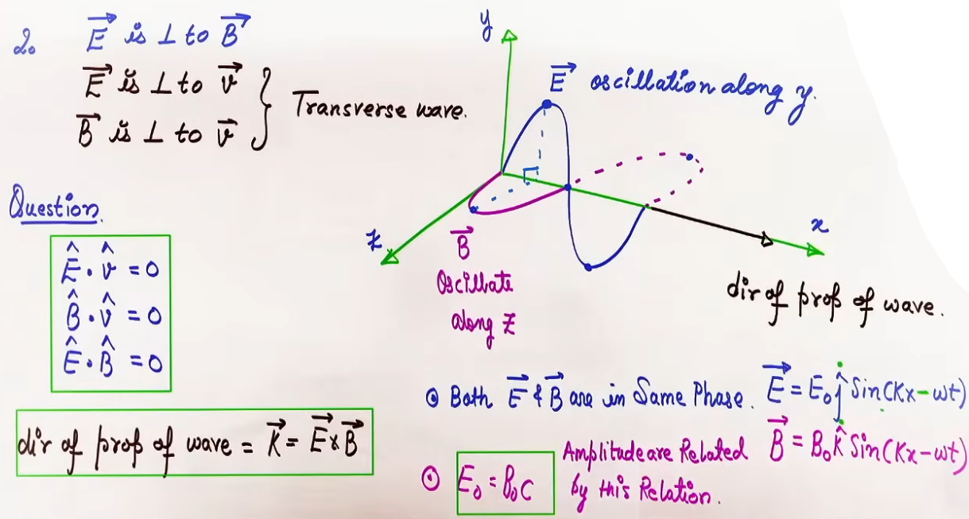

- Phase Synchronicity:
Electric field E and Magnetic field B in an EM wave oscillate in the EXACT SAME PHASE (Phase difference Δϕ = 0).
Both E and B reach their maximum peak amplitudes simultaneously and cross zero simultaneously.
Equations for wave propagating along +x axis:
E(x, t) = E₀ * j_cap * sin(k*x - ω*t)
B(x, t) = B₀ * k_cap * sin(k*x - ω*t)

- Amplitude Ratio Relationship:
In Vacuum: E₀ / B₀ = c => E₀ = B₀ * c # E = Bc
In Medium: E₀ / B₀ = v => E₀ = B₀ * v
RMS Relation: E_rms / B_rms = c

------------

- Wave Propagation Across Medium Boundaries:

1. Frequency (f or ν) remains strictly CONSTANT because frequency is determined solely by the wave source.
2. Wave speed (v) and wavelength (λ) change when entering a new medium:v=f*λ.
3. Speed in vacuum: c = 1 / √(μ₀*ε₀) ≈ 3 × 10⁸ m/s
4. Speed in medium: v = 1 / √(μ*ε) = 1 / √(μ₀μ_r * ε₀ε_r)
# μ_r = μ/μ₀; ε_r = ε/ε₀
5. Refractive Index (n or μ_ref): n = c/v = √(μ_r*ε_r)
6. For non-magnetic dielectric media (μ_r = 1): n = √ε_r = √K, where K is the dielectric constant (relative permittivity ε_r).
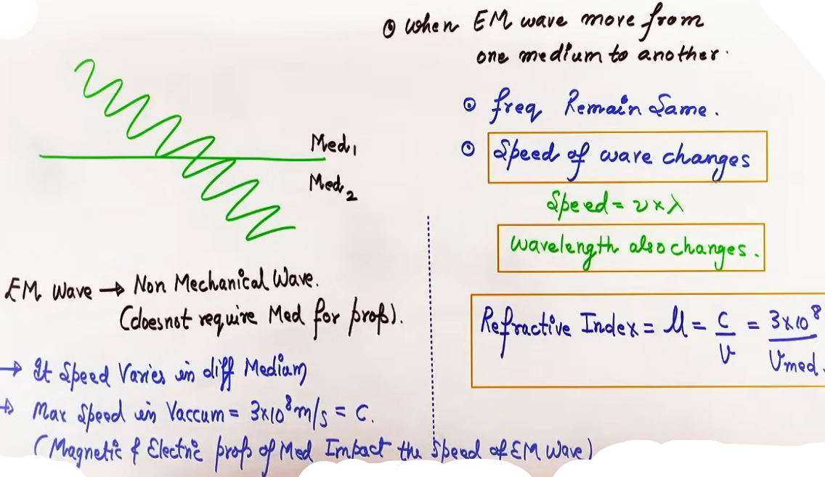

Energy Densities of EM Waves

# Full-Cycle Average of Squared Trigonometric Terms:
# <sin²(k*x - ω*t)> = 1/2, <cos²(k*x - ω*t)> = 1/2
# RMS Field Relationships:
# E_rms = E₀ / √2, B_rms = B₀ / √2

- Instantaneous Electric Energy Density (u_E):
u_E = (1/2)*ε₀*E² = (1/2)*ε₀*E₀²*sin²(k*x - ω*t)

- Average Electric Energy Density (<u_E>):
<u_E> = (1/4)*ε₀*E₀² = (1/2)*ε₀*E_rms²

- Instantaneous Magnetic Energy Density (u_B):
u_B = B²/(2μ₀) = (B₀²/(2*μ₀))*sin²(k*x - ω*t)

- Average Magnetic Energy Density (<u_B>):
<u_B> = B₀²/(4μ₀) = B_rms²/(2μ₀)

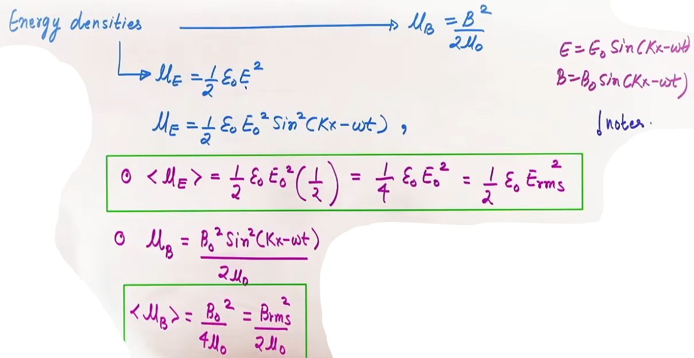
- Equal Energy Partition Theorem:
In an EM wave, energy is divided EQUALLY between electric and magnetic fields:
i.e. <u_E> = <u_B>

- Total Average Energy Density (<u_total>):
<u_total> = <u_E> + <u_B> = 2 * <u_E> = 2 * <u_B>
In terms of Peak Amplitudes: <u_total> = (1/2)*ε₀*E₀² = B₀²/(2μ₀)
In terms of RMS Values: <u_total> = ε₀*E_rms² = B_rms²/μ₀

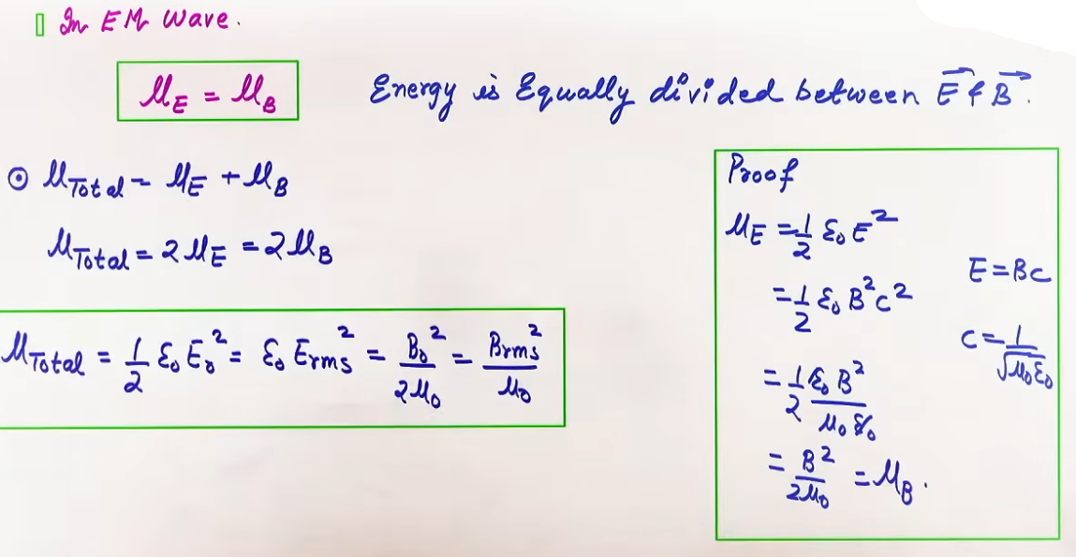

Intensity of EM Waves (I)

- Definition: Power delivered per unit cross-sectional area perpendicular to the direction of wave propagation.
Intensity I = Power/Area = Energy/(Area × Time)
SI Unit: Watt per square meter (W/m²)

- Point Source Geometry:
For an isotropic point source radiating total power P in 3D space, the wave front is spherical with surface area 4π*r² at distance r:
I(r) = P/(4πr²)
Intensity obeys the inverse-square law: I ∝ 1 / r²

- Fundamental Relation to Energy Density:
Intensity equals total average energy density multiplied by wave speed:
I = <u_total> * c

- Formulas for Intensity (I):
In terms of Peak Electric Amplitude E₀: I = (1/2)ε₀E₀²c
In terms of RMS Electric Field E_rms : I = ε₀E_rms²c
In terms of Peak Magnetic Amplitude B₀: I = (B₀²c/(2μ₀))
In terms of RMS Magnetic Field B_rms : I = (B_rms²c/μ₀)

- Peak Electric Field in Terms of Intensity:
E₀ = √[ (2I)/(ε₀*c) ] # uppar wale formula se hi nikala h

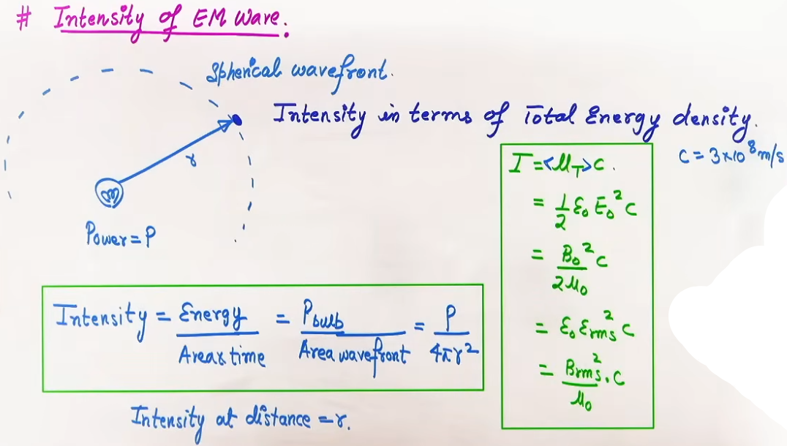
INTUITION AND CONCEPTUAL UNDERSTANDING
- Mental Model - Traveling Wave Phase Bracket:
Think of the phase bracket (kx - ωt) as a conveyor belt. To keep your position on the same wave height (constant phase), if time t advances forward, position x must move in the positive direction to keep (kx - ωt) constant. Hence (kx - ωt) represents wave motion in the +x direction. Conversely, in (kx + ωt), as t increases, x must decrease (move left) to hold phase constant, representing motion in the -x direction.

- Teacher's Intuitive "KV" Rule for Wave Speed:
To quickly find wave velocity from an equation, remember "ω = KV" (Kendra Vidyalaya rule). Angular frequency ω is always the coefficient of time t, and wave number k is always the coefficient of spatial position (x, y, or z). Thus, wave velocity v is simply (coefficient of t) divided by (coefficient of spatial position).

- Self-Sustaining Regenerative Loop of EM Waves:
An oscillating charge creates a time-varying electric field E. By Ampere-Maxwell law, changing E induces a perpendicular changing magnetic field B. By Faraday's law, changing B in turn induces a perpendicular changing electric field E further along. The two fields continuously regenerate each other, allowing the wave to propel through empty space without needing air or any mechanical medium.

- Energy Equal Partition Intuition:
Although electric field amplitude E₀ (e.g. 36 V/m) appears numerically vast compared to magnetic amplitude B₀ (e.g. 1.2 × 10⁻⁷ T), their energy contribution is EXACTLY 50%-50%. Why? Because magnetic field acts over permeability μ₀ (which is very small in denominator, 4π×10⁻⁷), while electric field acts over permittivity ε₀ (very small in numerator, 8.85×10⁻¹²). When calculated, <u_E> equals <u_B> precisely.

- Light Vector and Eye Sensitivity:
Why is E called the Light Vector and not B? The Lorentz force on a charged particle is F = q(E + v × B). For charged particles in biological cells, particle speed v is far smaller than light speed c (v << c). Thus, magnetic force q(v × B) is negligible compared to electric force qE (since B = E/c, magnetic force is of order (v/c)*qE << qE). Thus, electric field dominates all physical and visual interactions.
FORMULA SHEET

- Angular Wave Number: k = 2π / λ
- Angular Frequency: ω = 2π / T = 2π * ν
- Wave Speed: v = ν * λ = ω / k (Shortcut: ω = k * v)
- Speed of Light in Vacuum: c = 1 / √(μ₀ * ε₀) ≈ 3 × 10⁸ m/s
- Speed of EM Wave in Medium: v = 1 / √(μ * ε) = 1 / √(μ₀ * μ_r * ε₀ * ε_r)
- Refractive Index: n = c / v = √(μ_r * ε_r)
- Refractive Index for Non-Magnetic Medium (μ_r = 1): n = √ε_r = √K
- Vector Triad Rules:
e_cap × b_cap = v_cap
E · B = 0, E · v = 0, B · v = 0
- Amplitude Relation: E₀ = B₀ * c (In medium: E₀ = B₀ * v)
- RMS Relations: E_rms = E₀ / √2, B_rms = B₀ / √2
- Average Electric Energy Density: <u_E> = (1/4) * ε₀ * E₀² = (1/2) * ε₀ * E_rms²
- Average Magnetic Energy Density: <u_B> = B₀² / (4 * μ₀) = B_rms² / (2 * μ₀)
- Energy Equality: <u_E> = <u_B>
- Total Average Energy Density: <u_total> = (1/2) * ε₀ * E₀² = ε₀ * E_rms² = B₀² / (2 * μ₀) = B_rms² / μ₀
- Intensity from Point Source: I = P / (4 * π * r²)
- Intensity in terms of Energy Density: I = <u_total> * c
- Intensity Formulas:
I = (1/2) * ε₀ * E₀² * c = ε₀ * E_rms² * c
I = (B₀² / (2 * μ₀)) * c = (B_rms² / μ₀) * c
- Peak Electric Field from Intensity: E₀ = √ [ (2 * I) / (ε₀ * c) ]

Parameter Comparison Table for EM Wave Energy Densities:
Quantity | Formula in Peak Values (E₀, B₀) | Formula in RMS Values (E_rms, B_rms)
Electric Energy Density <u_E> | (1/4)*ε₀*E₀² | (1/2)*ε₀*E_rms²
Magnetic Energy Density <u_B> | B₀²/(4μ₀) | B_rms²/(2μ₀)
Total Energy Density <u_total> | (1/2)*ε₀*E₀² or B₀²/(2μ₀) | ε₀*E_rms² or B_rms²/μ₀
Intensity I | (1/2)*ε₀*E₀²*c | ε₀*E_rms²*c

EXAMPLES AND APPLICATIONS

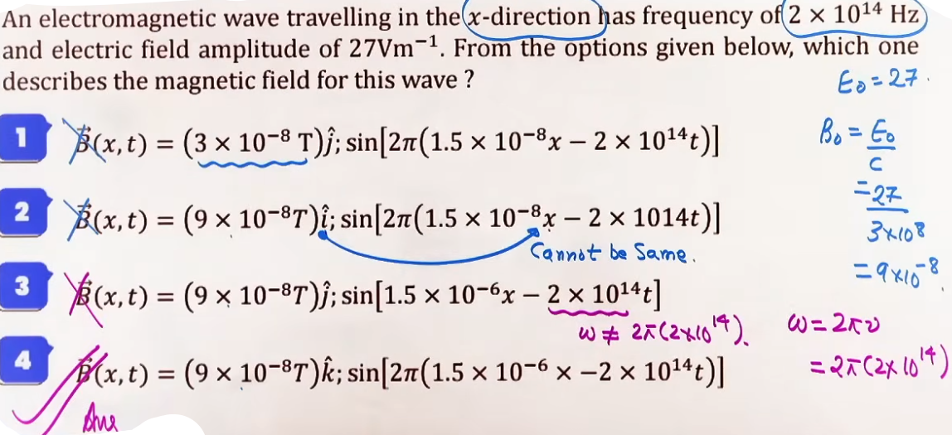

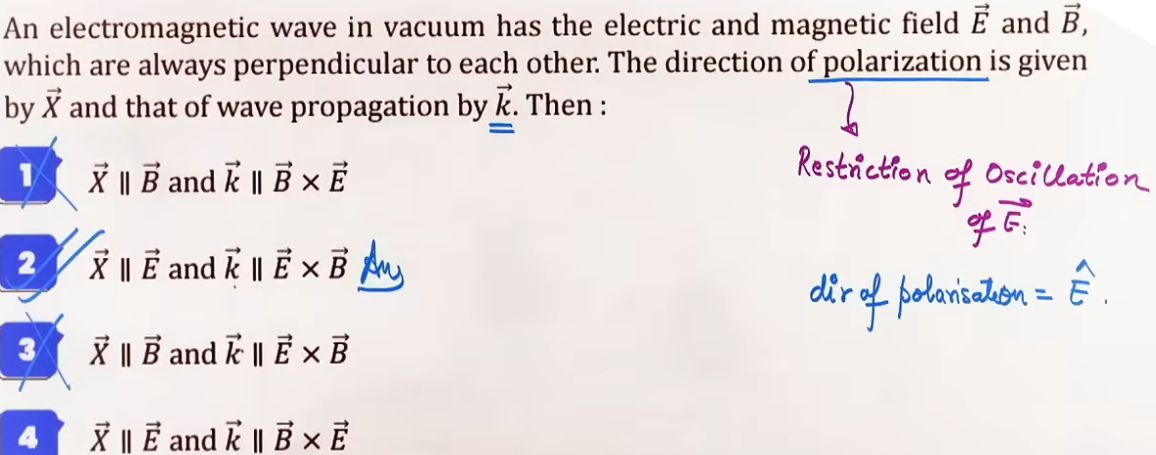
Example 1: Dielectric Constant K from Traveling Wave Equation
Problem: An EM wave traveling in a non-magnetic medium is described by E = 10 * j_cap * sin(4×10⁻⁷ * x - 50 * t) V/m. Calculate the dielectric constant K of the medium.

Solution:
1. Extract wave parameters from phase (k*x - ω*t):
k = 4 × 10⁻⁷ rad/m
ω = 50 rad/s
2. Wave velocity in medium:
v = ω / k = 50 / (4 × 10⁻⁷) = 1.25 × 10⁸ m/s
3. Refractive index n:
n = c / v = (3 × 10⁸) / (1.25 × 10⁸) = 2.4
4. Dielectric constant K (for non-magnetic medium μ_r = 1):
K = n² = (2.4)² = 5.76

Example 2: Spatial Distance Between Zero Nodes
Problem: An EM wave traveling along z-axis has E = 0 at position z₁ at time t₁. The next spatial position where E = 0 at time t₁ is z₂. If |z₂ - z₁| = 0.5 m, find the frequency of the wave in vacuum.

Solution:
1. Spatial distance between consecutive zero nodes along wave propagation axis is λ / 2:
λ / 2 = |z₂ - z₁| = 0.5 m => λ = 1.0 m.
2. Frequency:
f = c / λ = (3 × 10⁸) / 1.0 = 3 × 10⁸ Hz = 300 MHz.

JEE ADVANCED INSIGHTS

1. Equal Energy Density in All Media:
In any linear dielectric or magnetic medium, the average energy density remains split 50%-50% between electric and magnetic fields:
<u_E> = (1/4) * ε₀ * ε_r * E₀²
<u_B> = B₀² / (4 * μ₀ * μ_r)
Equating <u_E> = <u_B> directly gives E₀ / B₀ = 1 / √(μ*ε) = v (medium wave speed).

2. Vector Dot Product Elimination Shortcut:
In JEE Advanced multiple-choice options for E and B vectors, instantly eliminate any option where:
E · B ≠ 0, E · v ≠ 0, or B · v ≠ 0.
Additionally, verify that e_cap × b_cap = v_cap (right-hand rule).

3. Polarization Orientation Principle:
Direction of polarization is defined EXCLUSIVELY by the orientation of the Electric field vector E (Light vector). It is never defined by B or v.

4. Point Source Power and Field Scaling:
For an isotropic point source emitting power P:
Intensity I(r) = P / (4πr²) ∝ 1 / r²
Since I ∝ E₀², electric field amplitude scales as E₀(r) ∝ 1 / r.
Magnetic field amplitude scales as B₀(r) ∝ 1 / r.

COMMON MISTAKES AND TRAPS

Mistake | Why Students Make It | Correct Approach / Thinking
Using 1/2 instead of 1/4 for <u_E> with peak E₀ | Confusing peak value E₀ formula with RMS value formula | <u_E> = (1/4)ε₀E₀² when using peak E₀. <u_E> = (1/2)ε₀E_rms² when using RMS E_rms.
Assuming (+ωt) in bracket means +x direction | Misinterpreting wave phase translation | (kx + ωt) represents wave propagating along NEGATIVE axis (-x). (kx - ωt) represents POSITIVE axis (+x).
Introducing 90° Phase Shift between E and B | Confusing spatial perpendicularity with phase shift | E and B are spatially perpendicular but in EXACT SAME PHASE (Δϕ = 0). Phase expression inside sin/cos is identical for both.
Writing E₀ = B₀ / c instead of E₀ = B₀*c | Misremembering amplitude conversion ratio | E₀ = B₀ * c. E₀ in SI units (V/m) is 3×10⁸ times larger than B₀ in Tesla.
Assuming Frequency Changes in Medium | Believing wave speed change alters frequency | Frequency f depends strictly on source and NEVER changes across media. Speed v and wavelength λ change.

HIGH-YIELD REVISION SHEET

MUST REMEMBER:

Key Formulas:
- Wave Speed: v = f * λ = ω / k (Shortcut: ω = k * v)
- Speed in Vacuum: c = 1 / √(μ₀ * ε₀) ≈ 3 × 10⁸ m/s
- Speed in Medium: v = 1 / √(μ * ε); Refractive Index n = c / v = √(μ_r * ε_r)
- Non-magnetic Medium (μ_r = 1): n = √ε_r = √K
- Vector Triad: e_cap × b_cap = v_cap; E · B = 0; E · v = 0; B · v = 0
- Amplitude Relation: E₀ = B₀ * c; E_rms = E₀ / √2; B_rms = B₀ / √2
- Average Energy Densities: <u_E> = (1/4)ε₀E₀² = (1/2)ε₀E_rms²; <u_B> = B₀²/(4μ₀) = B_rms²/(2μ₀)
- Energy Equality: <u_E> = <u_B> = (1/2) <u_total>
- Total Average Energy Density: <u_total> = (1/2)ε₀E₀² = ε₀E_rms² = B₀²/(2μ₀) = B_rms²/μ₀
- Intensity: I = <u_total> * c = (1/2)ε₀E₀²c = ε₀E_rms²c = P/(4πr²)
- Peak Electric Field from Intensity: E₀ = √[ (2I)/(ε₀c) ]

